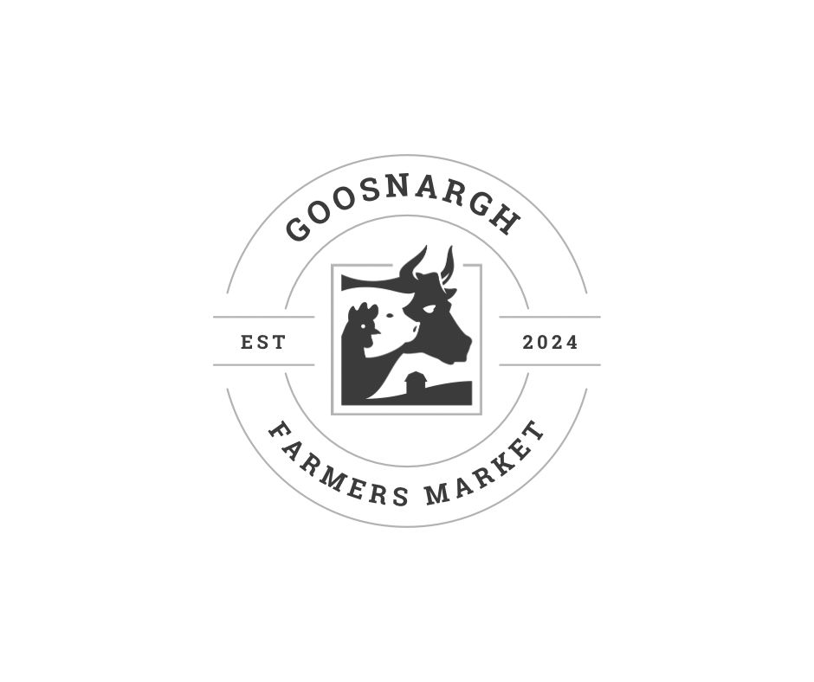

Application Form
Summer Food Festival
17 August 2024.
Whittingham & Goosnargh Social Club
Old Whittingham Hospital Grounds, Whittingham,
Preston,
United Kingdom,
PR3 2JE
Email: goosnarghfarmersmarket@gmail.com
Website: www.goosnarghfarmersmarket.co.uk
Please complete and return to the above email address, closing date for applications is 31st July 2024
Applications will not be considered unless all required information is completed in full.
Pitch Fees are to be paid in full on acceptance of application, a confirmation email and invoice will be sent to you, this will secure your
Space. Cancellation of your Booking less than 21 days before the event cannot not be refunded.

Food Festival Application
Company Name:

Contact Name:

Address:

Email:

Tel No:

Website

Facebook

Instagram

Local Authority your business is registered with
Risk Assessment (compulsory) | Y/N
Public Liability Attached (compulsory). Name of Insurer & Policy No | Y/N
Description/Content
Of your Stand:
(please state exact nature of your business including products)

Trade Pitches: (please tick your requirements)
Inside Pitch with a table (single)  £30.00 | Inside Pitch with a table (Double)  £60.00 | Outside Pitch space only (Single 3m x 3m)  £30.00 | Outside Pitch space only (double 6m x 3m)  £60.00
Outside Pitch with Gazebo Provided (Single 3 m x3m)  £40.00 | Outside Pitch with Gazebo Provided (Double 6 m x3m)  £80.00 | Electric  £5.00
I/we
I/we have applied for trade stand space as filled in above, I/we understand that should the application be successful an invoice will be sent shortly which must be paid in full to secure mine/our booking.
I have returned a completed a risk assessment form.
By signing this form, I accept the booking conditions.
Signed:……………………………………… Date: ……………………..

